[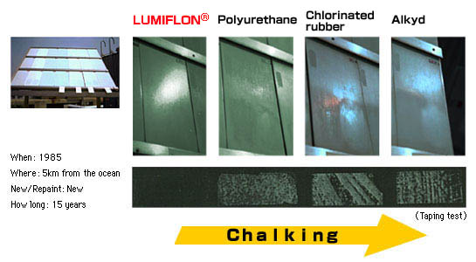](http://www.lumiflon.com/what_us/testp_img01.jpg)